Calculus 1 Lecture 1.5: Slope of a Curve, Velocity, and Rates of Change

Tangent lines and rates of change
Using limits to find the slope of the tangent to a curve at a point

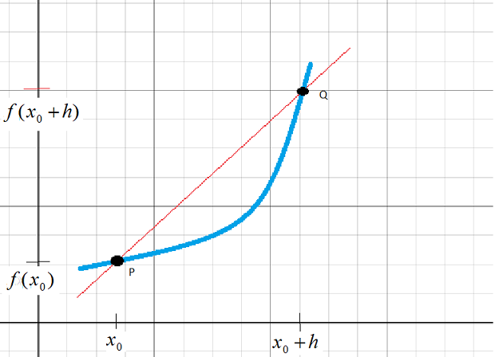

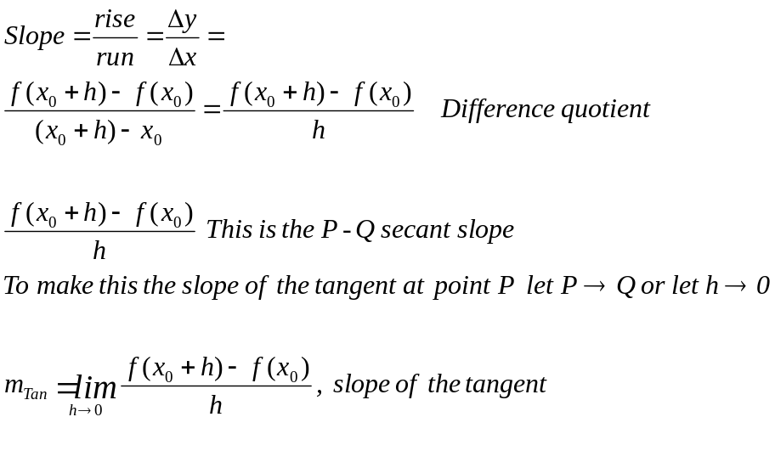
Example
Find the equation of the tangent line to 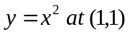
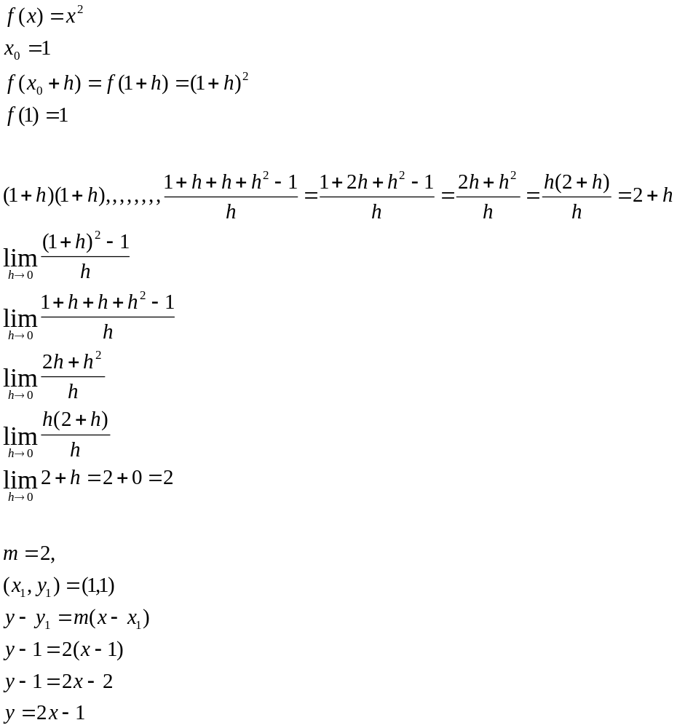

Example
Find the equation of the tangent line to 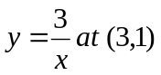
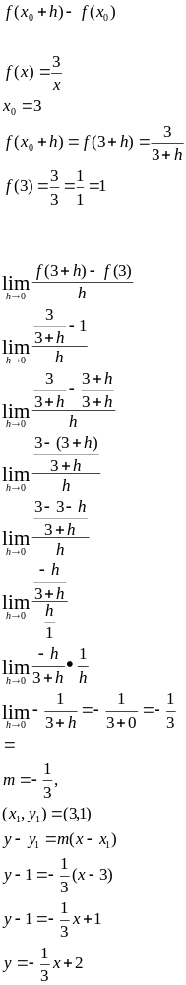
Example
Find the slope of the tangent lines to 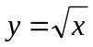 at any point

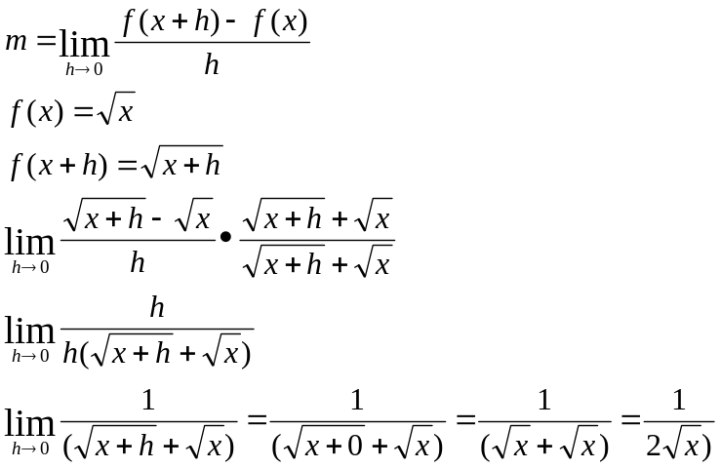

Average velocity
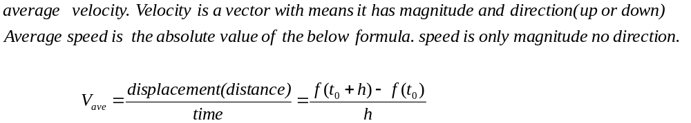

Example
Find average velocity of 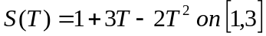
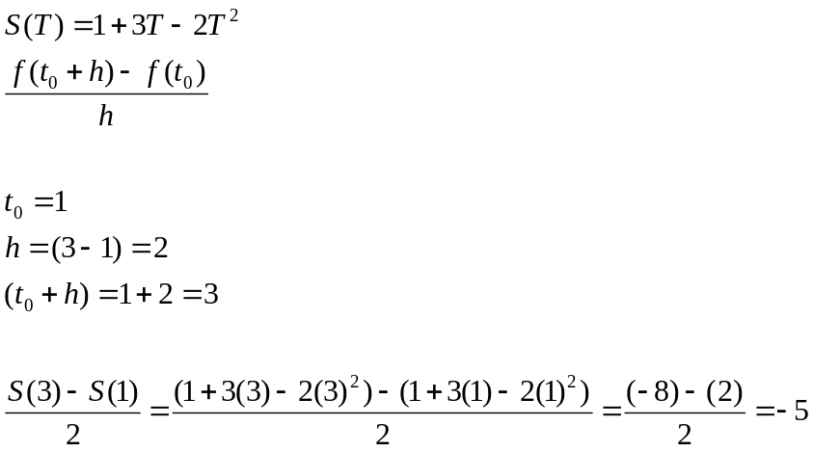

Instantaneous velocity
The slope of a curve at a point is Instantaneous velocity.

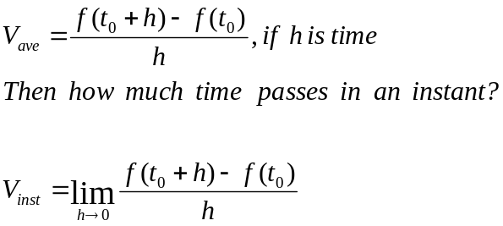

Example
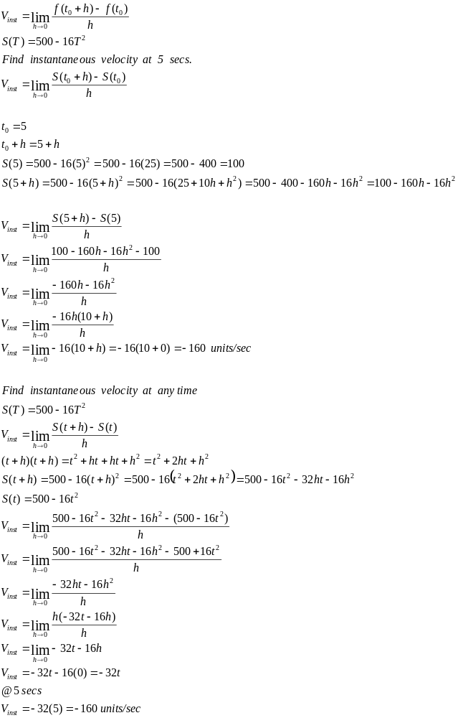

Rates of change
The slope is a rate of change.
The slope of a curve at a point is Instantaneous rate of change.
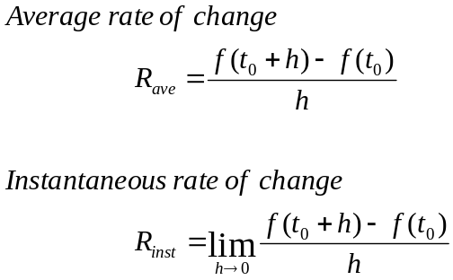

Example
